Permanent position 3-5 days per week, Saturdays essential
Rate of pay: £13.50 per hour
Additional hours: Opportunity for Sunday overtime when the theatre is open.

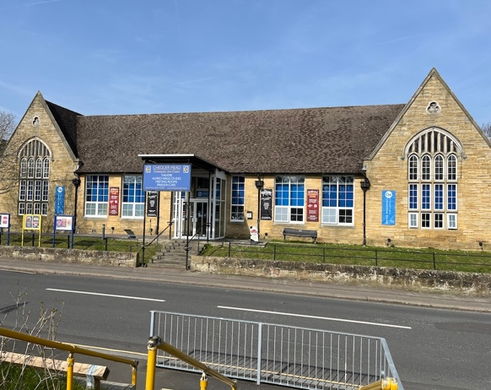
The Apron is Chequer Mead's welcoming café, casual dining and bar space, serving both the local community and theatre visitors. Our menus offer a varied selection of food and drink to suit a range of tastes and occasions.

As part of a busy theatre venue, The Apron has a varied and lively atmosphere, serving customers throughout the day before transforming into a busy bar supporting the theatre's evening performances and events. We also host occasional live music events and have a lovely courtyard garden which is particularly popular during the summer months.

Chequer Mead hosts over 250 events per year, both in the main auditorium and throughout the venue. The theatre offers a mixed programme of professional and community events and hosts many other events across the year.
The Apron is open during the daytime six days per week, Monday to Saturday, serving food, coffee and drinks. In the evening and on Sundays, The Apron is open as a bar supporting the events being hosted by the Theatre. Additionally, The Apron hosts private catered events in the Apron and Studios.

The Role
We're looking for an experienced, enthusiastic and reliable Senior Barista & Catering Assistant to join our team at The Apron.
This is a varied, hands-on role for someone who loves great coffee, enjoys working in a busy food and hospitality environment and is confident taking responsibility for a team and the smooth running of a shift.
A key part of the role will be taking the lead on Saturdays, acting as the senior team member on shift and helping to supervise the team to ensure everything runs smoothly. You'll also need to be happy to turn your hand to the kitchen when required, supporting the wider team wherever you're needed.

Key Responsibilities
- Taking responsibility for the smooth running of our Saturday service and acting as the senior team member on shift.
- Supervising and supporting the Saturday team, ensuring high standards of service and customer experience.
- Preparing and serving excellent coffee and other drinks.
- Working confidently across our café and kitchen operations, providing kitchen cover when required.
- Helping with food preparation, catering and general kitchen duties.
- Supporting private catering events and theatre events when required.
- Helping to maintain a positive, organised and efficient working environment.
- Assisting with day-to-day operational tasks and providing additional support to the management team.

About You
We're looking for someone who:
- Has solid barista experience and is confident making great coffee.
- Has experience in hospitality, catering or a busy café environment.
- Is confident taking responsibility and leading a team during a shift.
- Is happy working across both front-of-house and kitchen duties.
- Is organised, proactive and able to think on their feet.
- Has a positive, flexible and helpful attitude.
- Enjoys being part of a close-knit team and takes pride in delivering great customer service.
Previous supervisory experience would be a real advantage.

Working Hours
- Ideally 3-5 days per week, with flexibility around which weekdays are worked.
- Saturday availability is essential. This is a key part of the role, with responsibility for overseeing the Saturday team and service.
- There may also be opportunities to work Sundays as overtime when we are open.
We're happy to discuss working patterns with the right person and are keen to find someone looking for a flexible but rewarding role.

Why Join Us?
You'll be joining a friendly, busy and welcoming team in a unique theatre and hospitality environment. No two days are quite the same, with a varied programme of theatre events, music, private functions and café service.
This is a great opportunity for someone who enjoys variety, likes taking ownership and wants to play an important role in the day-to-day running of The Apron.
Please note that the role is not limited to this description and may vary according to the needs of the venue.

Benefits
- Employee Assistance Programme (EAP)
- On-site Parking
- Staff discount on all food and soft drinks from The Apron
- Uniform (partial)

Interested? We'd love to hear from you!
Get in touch to tell us a little about yourself and your experience. Email your cv and a short cover letter to careers@chequermead.co.uk

