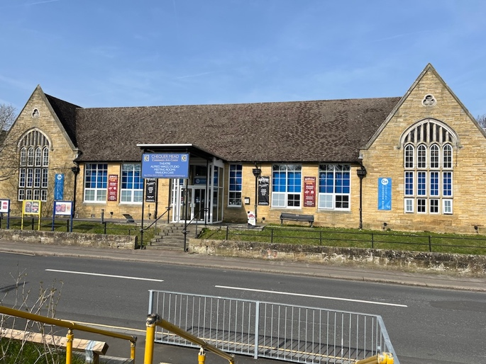
Zero-Hours Contract, Flexible Working
Rate of Pay: Competitive hourly rate in line with the National Minimum Wage, depending on age.

About The Apron and Chequer Mead
The Apron is Chequer Mead's welcoming café, casual dining and bar space, serving both the local community and theatre visitors. Our menus offer a varied selection of food and drink to suit a range of tastes and occasions.
As part of a busy theatre venue, The Apron has a varied and lively atmosphere, serving customers throughout the day before transforming into a busy bar supporting the theatre's evening performances and events. We also host occasional live music events and have a lovely courtyard garden which is particularly popular during the summer months.

The Role
We're looking for friendly, enthusiastic and reliable Bar Staff and Baristas to join our flexible team at The Apron.
Working on a zero-hours basis, this is a great opportunity for someone looking for flexible hospitality work, with shifts available across our daytime café, evening theatre bar and private events.
No two shifts are quite the same! You could be making coffees and serving customers during the day, serving drinks to theatre audiences in the evening or helping with a private function or catered event.

Key Responsibilities
- Preparing and serving coffee, hot drinks and other beverages.
- Serving customers in a friendly and welcoming manner.
- Working behind the bar during theatre performances and events.
- Serving food and supporting general café operations.
- Helping with food preparation and basic kitchen duties when required.
- Taking payments and handling customer transactions.
- Setting up and clearing down for events and functions.
- Keeping customer areas, café and bar spaces clean, tidy and well presented.
- Working as part of a team to ensure the smooth running of The Apron.

About You
We're looking for people who:
- Have a friendly, positive and helpful attitude.
- Enjoy working with people and delivering great customer service.
- Are reliable, flexible and happy to work as part of a team.
- Are comfortable working in a busy and sometimes fast-paced environment.
- Are happy to turn their hand to different tasks.
- Have good communication skills and a willingness to learn.
Previous bar, barista or hospitality experience would be an advantage, although a positive attitude and willingness to learn are just as important.

Working Hours
- Zero-hours contract, with shifts offered according to business requirements.
- Flexible opportunities across daytime, evening and weekend shifts.
- Availability for evenings and weekends would be particularly useful.
- Additional shifts may be available during busy theatre periods, private events and functions.

Why Join Us?
You'll be joining a friendly and welcoming team in a unique theatre and hospitality environment. It's a varied role with opportunities to gain experience across café service, bar work and catering, with the flexibility of zero-hours working.
Interested in joining us?
We'd love to hear from you! Get in touch and tell us a little about yourself and any relevant experience. Email your cv and a cover letter to careers@chequermead.co.uk
Location: The Apron, Chequer Mead, De La Warr Road, East Grinstead RH19 3BS.

